

Please add these storage options in forms

1. Promotional Popup

Please add **MailChimp and Google Drive** storage options in the promotional form popup because they are not currently available.

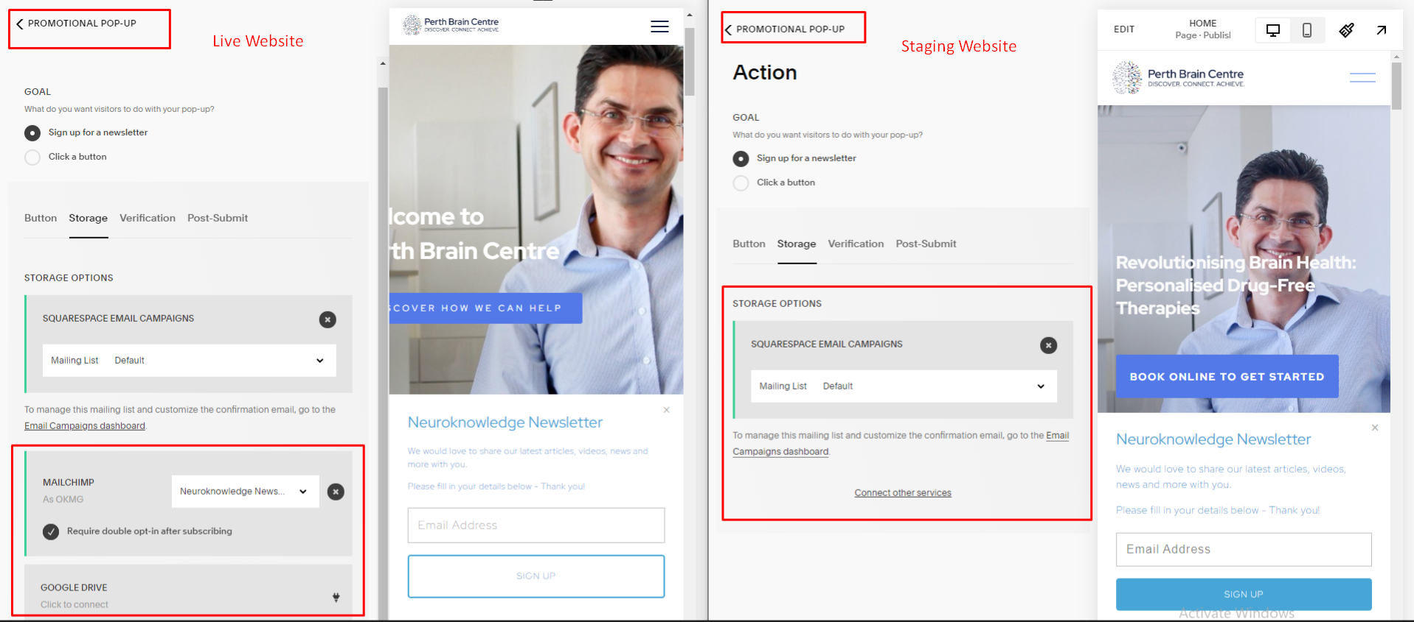

2. Contact Us form

**Page URL**  
<https://groundhog-paddlefish-dcd8.squarespace.com/contact-us>

Please add **Google Drive** storage options in the contact form because it is added on the live website but not on the staging.

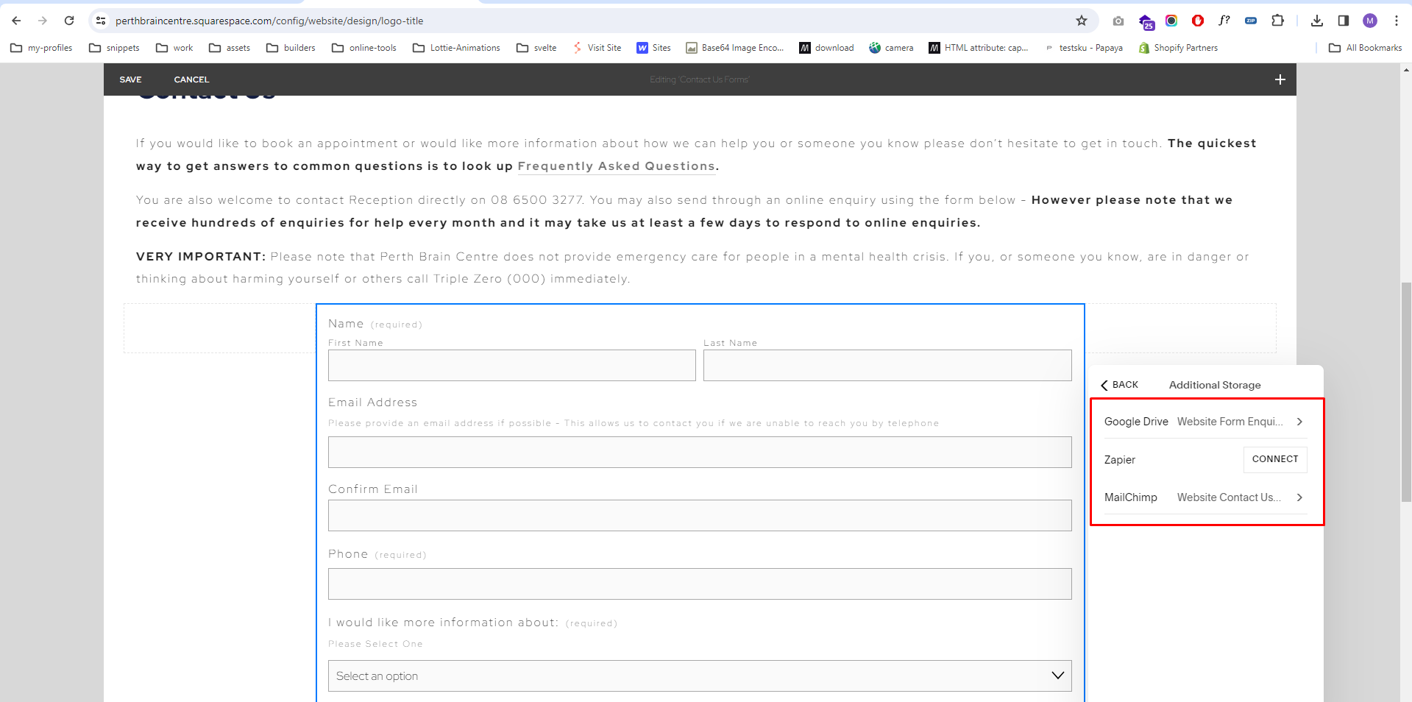

3. Newsletter signup

**Page URL**  
<https://groundhog-paddlefish-dcd8.squarespace.com/neuroknowledge/newsletter-sign-up>

Please add **MailChimp** storage options in this form because it is added on the live website but not on the staging.

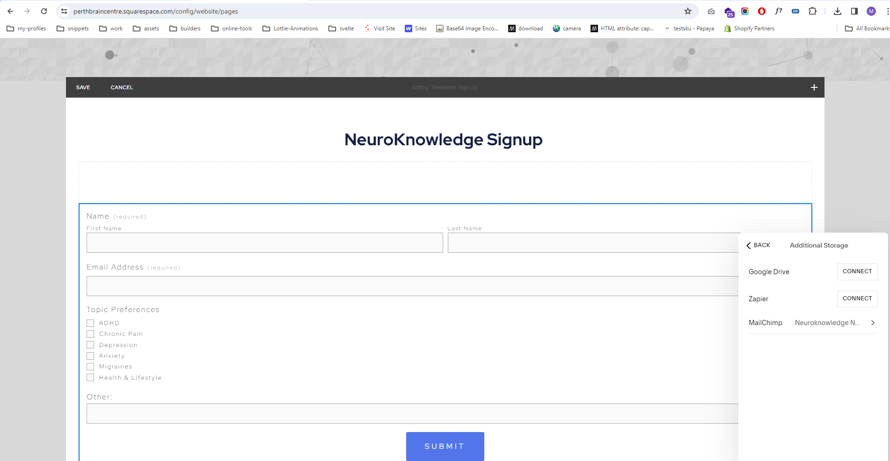

4. Feedback Form

**Page URL**  
<https://groundhog-paddlefish-dcd8.squarespace.com/feedback-form>

Please add **Google Drive** storage options in this form because it is added on the live website but not on the staging.

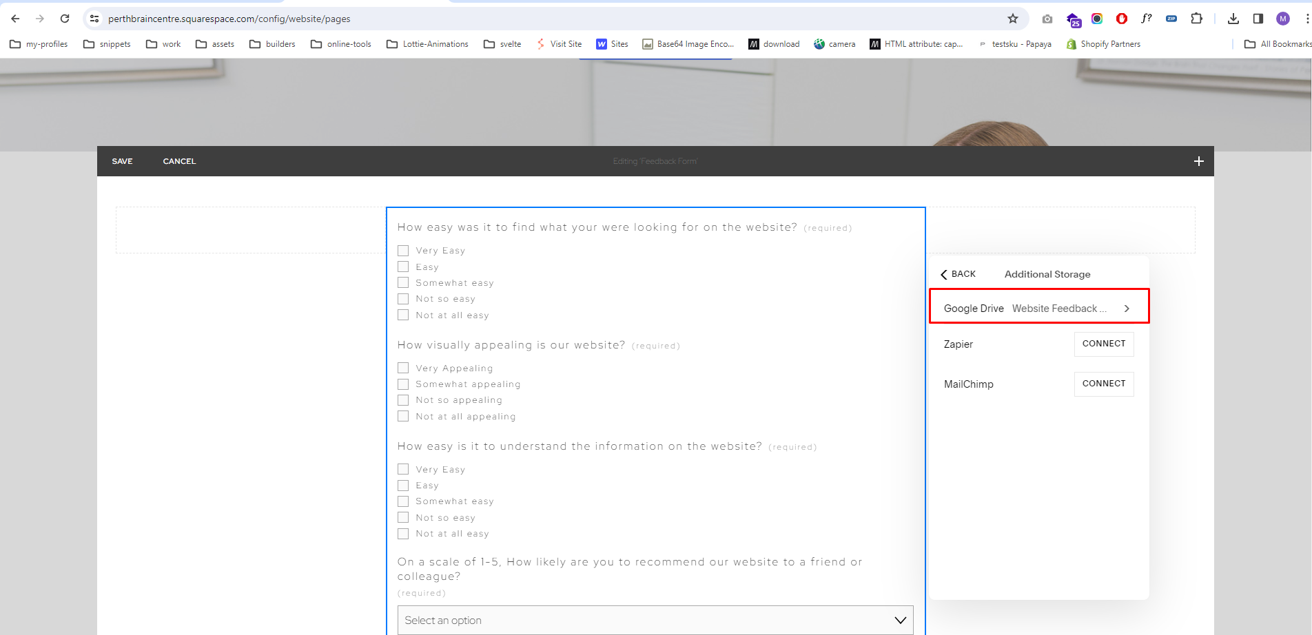

5. Health Professional Contact Us Form

**Page URL**  
<https://groundhog-paddlefish-dcd8.squarespace.com/health-professionals/contact-us>

Please add **MailChimp** storage options in this form because it is added on the live website but not on the staging.

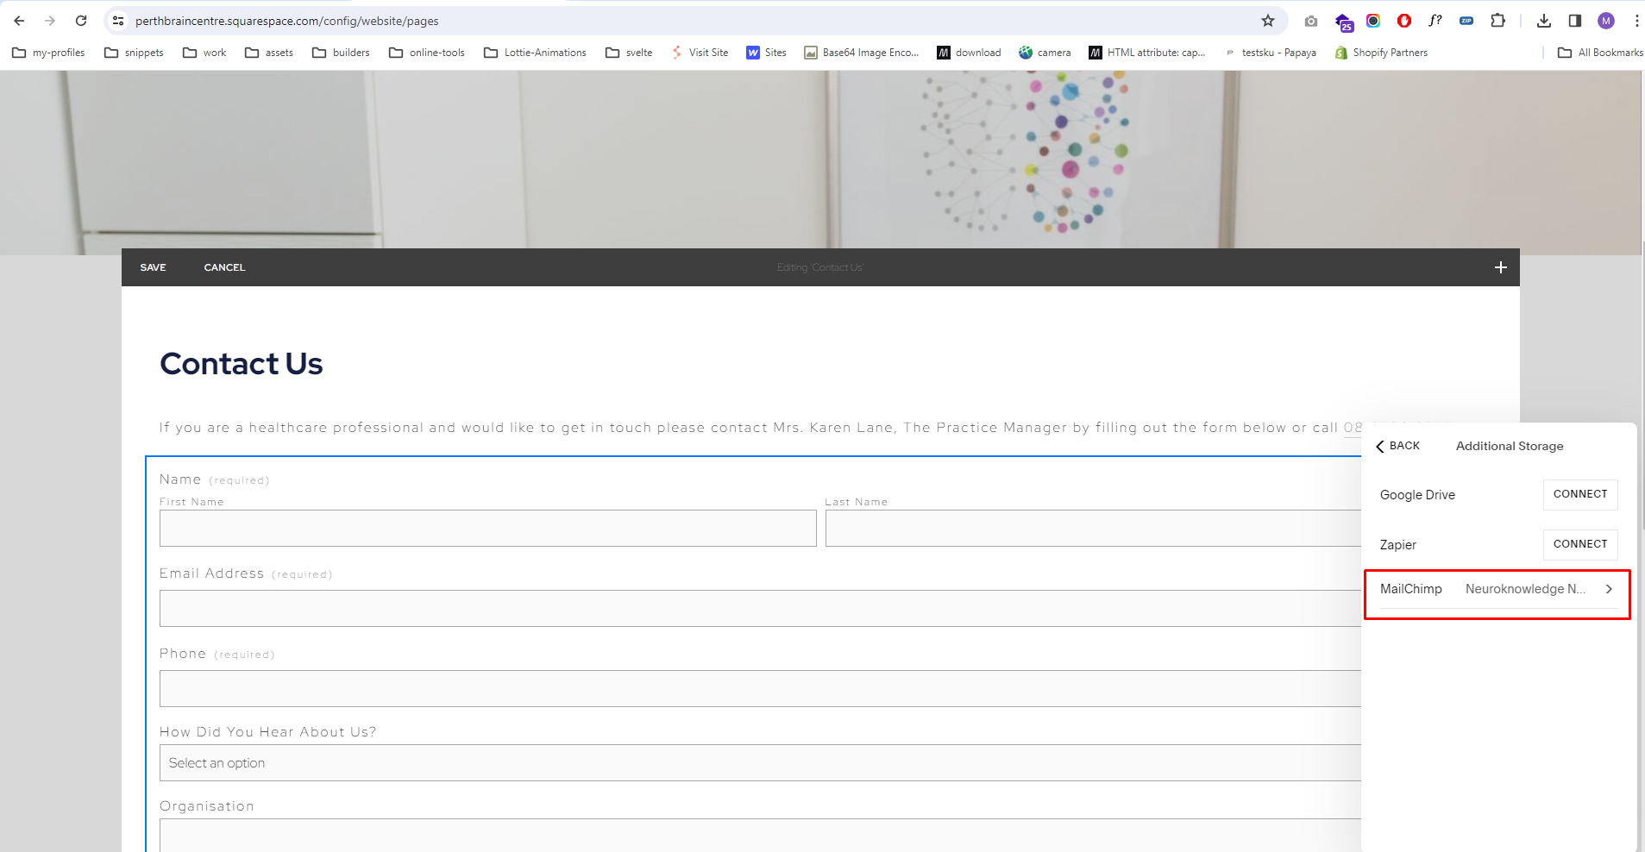

6. News & Events Registration Form

**Page URL**  
<https://groundhog-paddlefish-dcd8.squarespace.com/news-and-events>

Please add **MailChimp** storage options in this form because it is added on the live website but not on the staging.

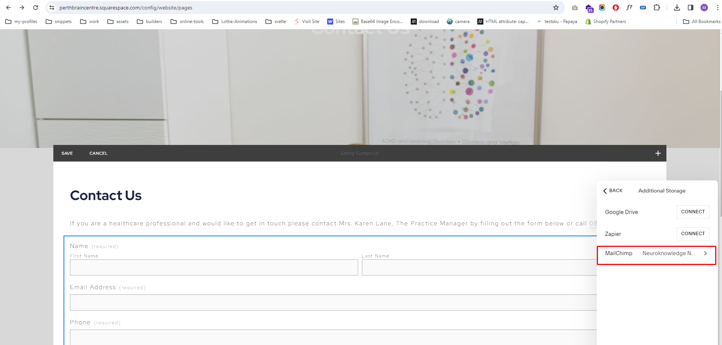

Third Party Tools

Please connect the account in the **Third Party Tools** option on the staging website as it has been added on the live website.

